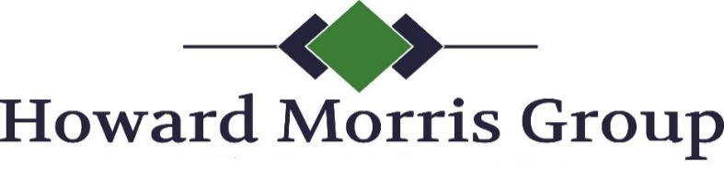
910 Walker Rd., Ste. B, Dover, DE 19904
Toll Free: 877-296-4726 Fax: 877-213-2664
accounting@howardmorrisgroup.com
One Time ACH Payment Authorization Form

Sign and complete this form to authorize Howard Morris Group to make a one-time payment to be processed via check.

By signing this form, you give us permission to debit your account for the amount indicated on or after the indicated date. This is permission for a single transaction only, and does not provide authorization for any additional unrelated debits or credits to your account.

Please complete the information below:

I ____________________________ authorize Howard Morris Group process a payment by my
(full name)
bank account indicated below for _____________ on or after ___________________.
(amount) (date)

Billing Address ____________________________ Phone# ________________________
City, State, Zip ____________________________ Email ________________________

Account Type: Checking Savings
Name on Acct _______________________________
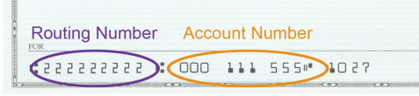
Bank Name _______________________________
Account Number _______________________________
Bank Routing # _______________________________
Check # _______________________________

SIGNATURE DATE

I understand that because this is an electronic transaction, these funds may be withdrawn from my account as soon as the above noted transaction date. In the case of the payment being rejected for Non Sufficient Funds (NSF) I understand that Howard Morris Group may at its discretion attempt to process the charge again within 30 days, and I agree to an additional $35.00 charge for each attempt returned NSF, which will be initiated as a separate transaction from the authorized payment. I acknowledge that the origination of ACH transactions to my account must comply with the provisions of U.S. law. I will not dispute Howard Morris Group’s or Merrick, Costello & Walsh’s billing with my bank so long as the transaction corresponds to the terms indicated in this agreement.

